Database Lab 11

Lab Done in Group Allowed by Ma’am

Name: Ahmed Kasteer

Roll Number: 20F-0336

Section: 4D

Name: Ali Booka

Roll Number: 18F-0232

Section: 4D

Question 1:

declare

n NUMBER := 15;

r NUMBER;

BEGIN

r := MOD(n, 2);

IF r = 0 THEN

dbms_output.Put_line(' Number is Even');

ELSE

dbms_output.Put_line('Number is Odd');

END IF;

END;

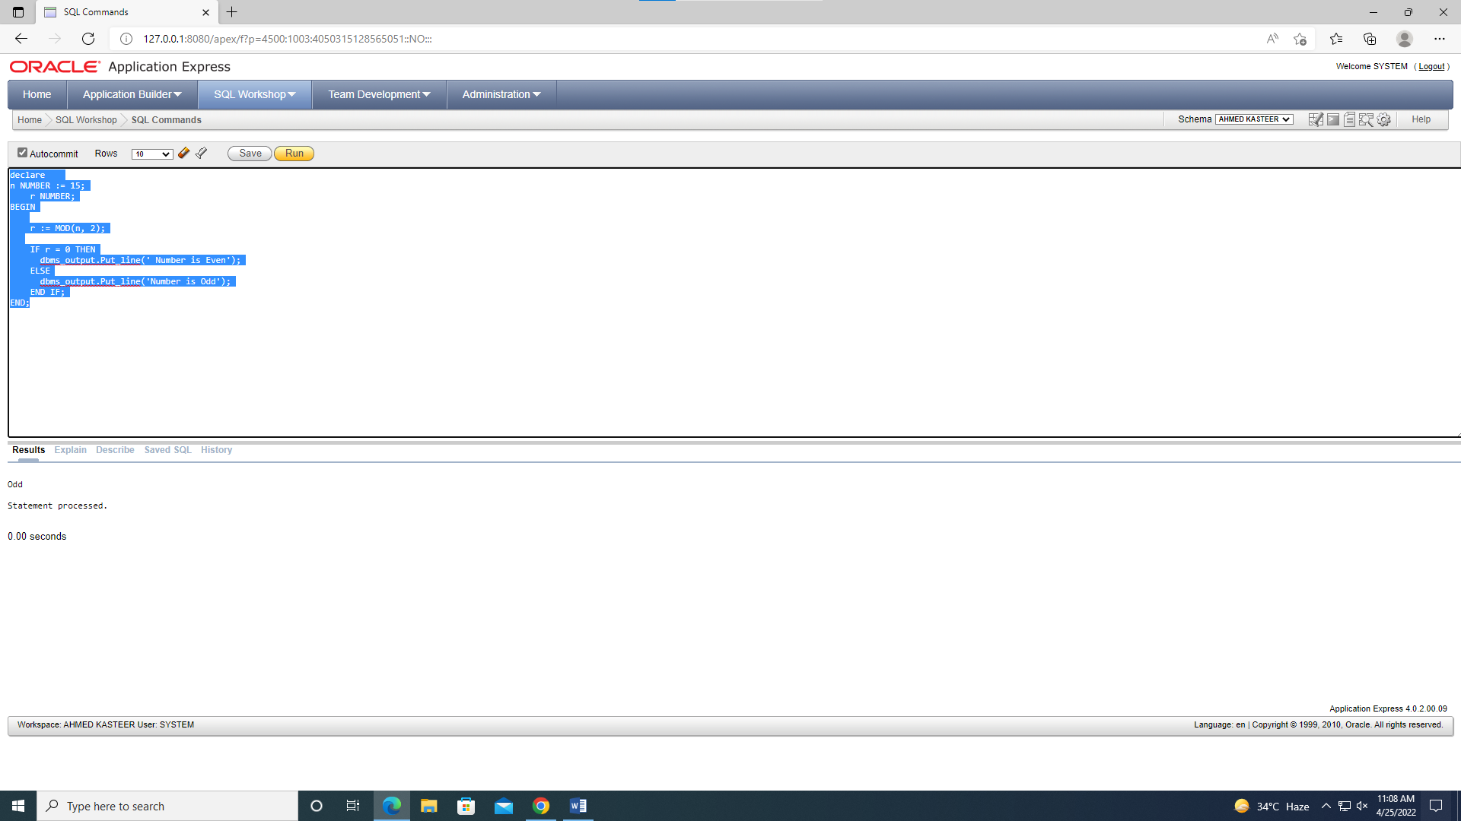

Question 2:

DECLARE

num1 NUMBER := 14;

BEGIN

IF num1 < 0 THEN

DBMS_OUTPUT.PUT_LINE ('The number '||num1||' is a negative number');

ELSIF num1 = 0 THEN

DBMS_OUTPUT.PUT_LINE ('The number '||num1||' is equal to zero');

ELSE

DBMS_OUTPUT.PUT_LINE ('The number '||num1||' is a positive number');

END IF;

END;

/

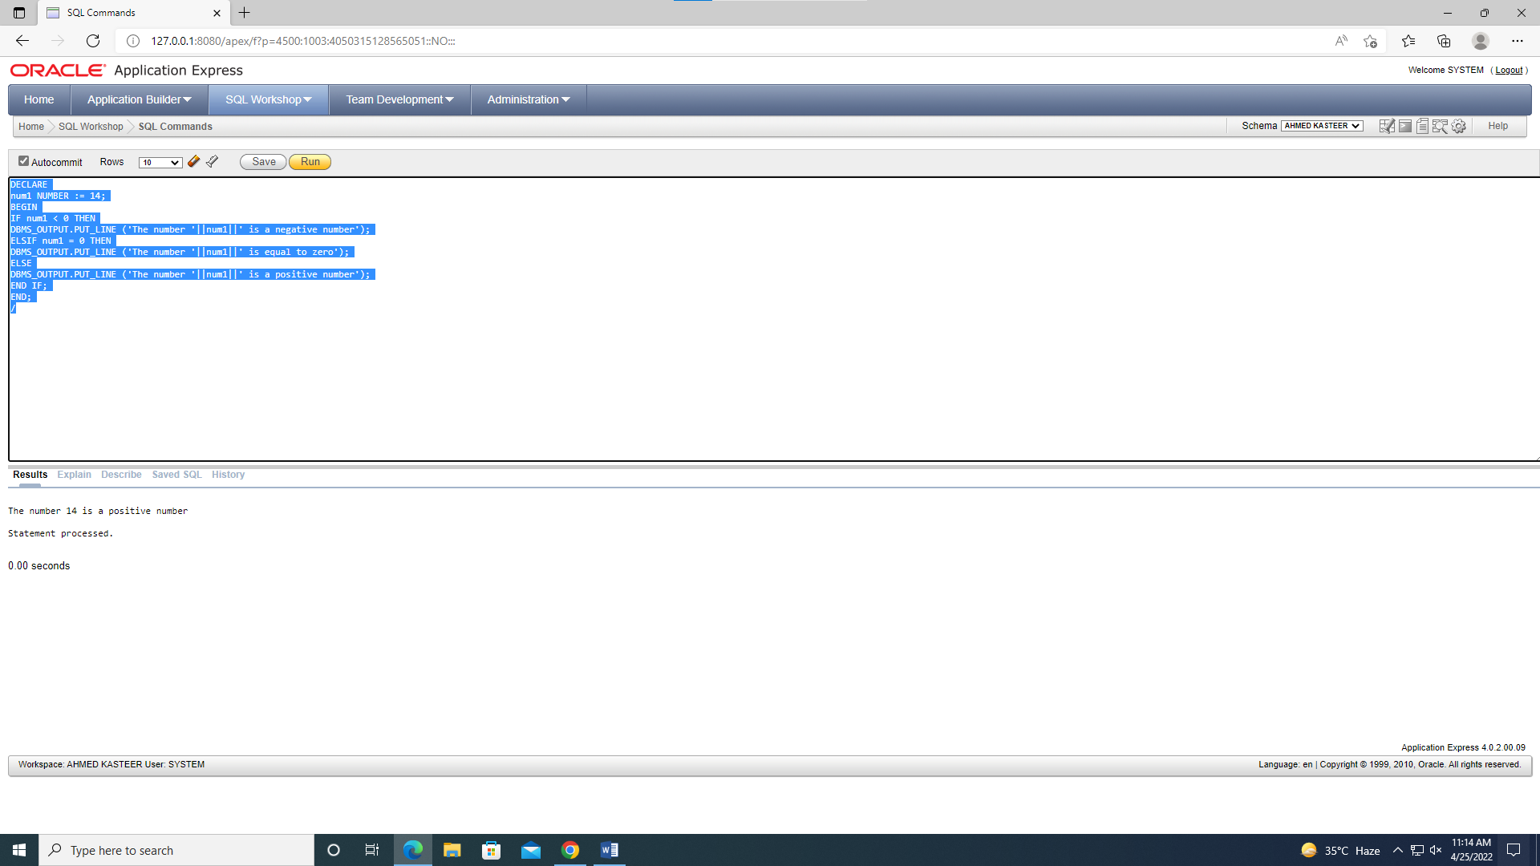

Question 3:

DECLARE

num_small NUMBER := 224;

num_large NUMBER := 125;

num_temporary NUMBER;

BEGIN

IF num_small > num_large THEN

num_temporary := num_small;

num_small := num_large;

num_large := num_temporary;

END IF;

DBMS_OUTPUT.PUT_LINE ('num_small = '||num_small);

DBMS_OUTPUT.PUT_LINE ('num_large = '||num_large);

END;

/

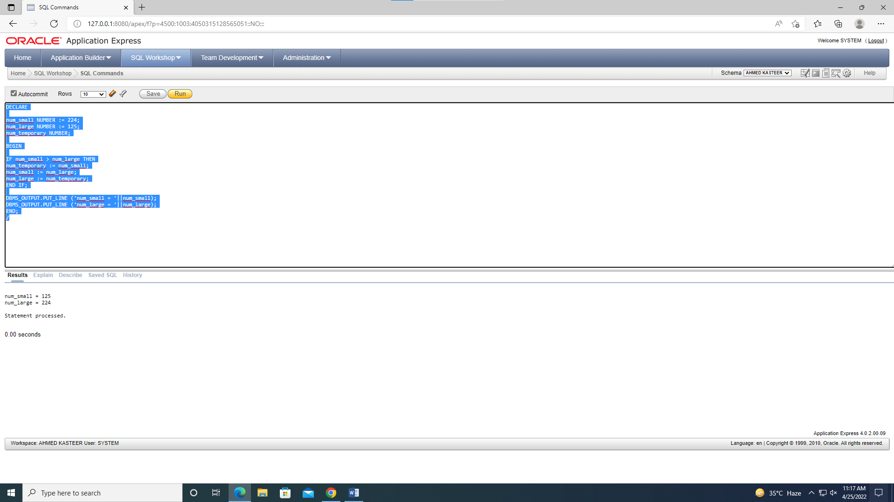

Question 4:

DECLARE

n number:= 20;

i number:=1;

num number:=1;

BEGIN

DBMS_OUTPUT.PUT_LINE ('The first n numbers till entered number: ');

dbms_output.new_line;

dbms_output.new_line;

DBMS_OUTPUT.PUT (i||' ');

for i in 1..n-1 loop

num:=num+1;

dbms_output.put(num||' ');

END LOOP;

dbms_output.new_line;

dbms_output.new_line;

END;

/

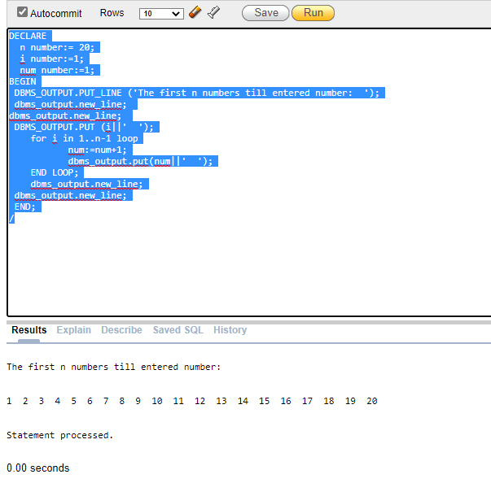

Question 5:

CREATE TABLE emp_temp(

emp_id NUMBER;

emp_email VARCHAR2(40)

);

DECLARE

number_of_emp NUMBER;

BEGN

SELECT COUNT (employee_id) INTO number_of_emp

FROM employees;

FOR i IN 1..number_of_emp LOOP

INSERT INTO emp_temp (emp_id, emp_email)

VALUES(i, 'not available now');

END LOOP;

END;

/

